|  |
| --- |
|  |
|  |

Chapter 1

**Introduction**

**1.1. AIMS AND OBJECTIVE**

Humans have been using physical characteristics such as face, voice, gait, etc. to recognize each other for thousands of years. With new advances in technology, biometrics has become an emerging technology for recognizing individuals using their biological traits. Now, biometrics is becoming part of day to day life, where in a person is recognized by his/her personal biological characteristics. Examples of different Biometric systems include Fingerprint recognition, Face recognition, Iris recognition, Retina recognition, Hand geometry, recognition, Signature recognition, among others. Face recognition, in particular has received a considerable attention in recent years both from the industry and the research community. The objective of our project is to create a C# code that can be used to identify people using their face images.

Using the face recognition technique we use in the attendance management system. With the help of the face recognition we make the attendance of the student.

**1.2 PROBLEM STATMENT**

Every time a lecture, section starts the lecturer or teaching .This is a lengthy process and takes a lot of time and effort, especially if it is a lecture with a huge number of students. It also causes a lot of disturbance and interruption when an exam is held. Moreover the attendance sheet is subjected to damage and loss while being passed on between different students or teaching staff. And when the number of students enrolled in a certain course is huge, the doctors tend to call a couple of student names at random which is not a fair student evaluation process either. Finally, these attendance records are used by the staff to monitor the students’ 3 attendance rates. This process could be easy and effective with a small number of students but on the other hand, dealing with the records of a large number of students often leads to human errors.

**1.3. SCOPE**

The proposed face recognition system works with limitations, and it does not work effectively when it finds high variation in pose and when database is large. Further research can be carried out to design a low resolution face recognition which works efficiently for large database and for face databases with high variation in pose. ANN grouping can be used to overcome the problem of face recognition with large data base and SVM classifiers can be used to improve the face recognition rate with high variation in pose.

Chapter 2

**Literature Review**

**2.1. BIOMTRICS**

Biometrics is the automated recognition of individuals based on their behavioural or physiological characteristics .The physiological characteristics are related to the shape of the body. The most common example is fingerprint. Other examples include face recognition, hand geometry and iris recognition. The behavioural characteristics are related to the behaviour of a person. Signature is one example of these characteristics which is still widely used today. Modern approaches are the study of keystroke dynamics and voice[2].

With the rapid development in the field of pattern recognition and its uses in different areas e.g. (signature recognition, facial recognition), arises the importance of the utilization of this technology in different areas in large organizations. This is mainly because these applications help the top-management take decisions that improve the performance and effectiveness of the organization. On the other hand, for an organization to be effective, it needs accurate and fast means of recording the performance of the people inside this organization. Biometric recognition has the potential to become an irreplaceable part of many identification systems used for evaluating the performance of those people working within the organization. Although biometric technologies are being applied in many fields it has not yet delivered its promise of guaranteeing automatic human recognition. This research is the first of its kind to attempt to provide an automated attendance system that recognizes students using face recognition technology through an image/video stream to record their attendance in lectures or sections and evaluating their performance accordingly.[3]

Face recognition is a biometric which uses computer software to determine the identity of the individual. Face recognition falls into the category of biometrics which is “the automatic recognition of a person using distinguishing traits” Other types of biometrics include fingerprinting, retina scans, and iris scan.[6]

Chapter 3

**Existing System**

Following are the Existing system for the attendance system:-

3.1. **Attendance take by manually** :- This is old version method for the attendance system where the teacher/staff/representative take the attendance by call the person name and tick in the attendance register. If it’s present then tick as present or absent.

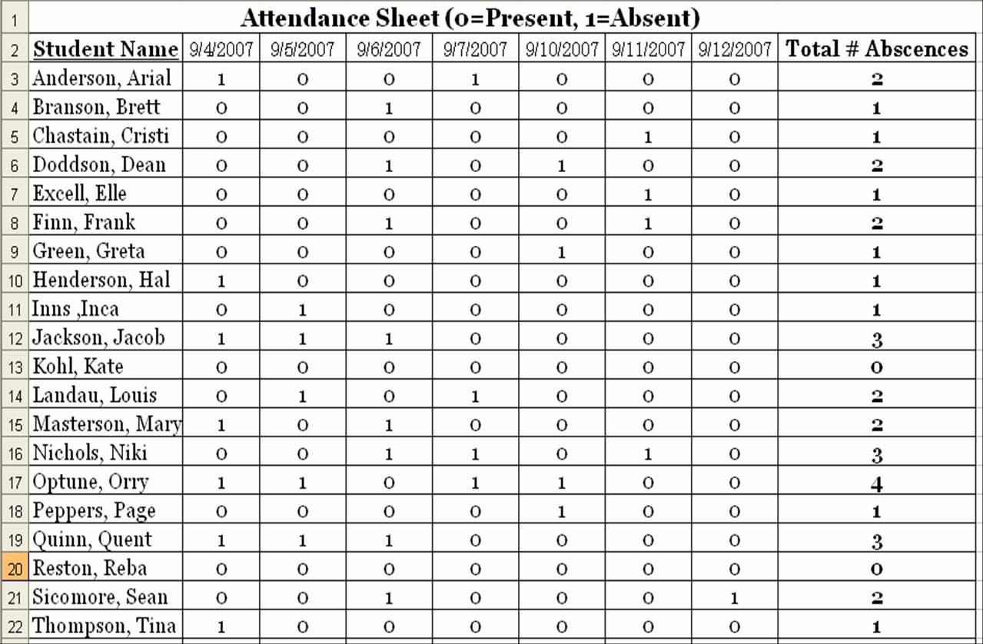

**Fig 3.1: Attendance sheet**

**3.2. Finger print attendance system** :- This is a system in which a persons finger print is detected by a laser and the attendance is marked.

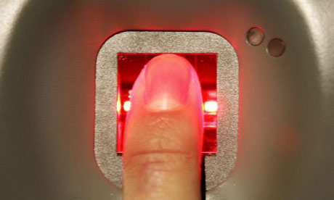

**Fig 3.2: Finger print**

**3.3. Retina scan** :- Retina of a eye is scaned individualy by a scanner and attendance is marked.

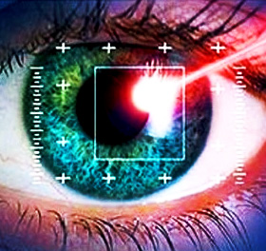

**Fig 3.3: Retina scan**

**3.4. ID card scanning system** :- The magnetic strip on the id card is scanned by a computer and information is collected and at the same time attendance is marked.

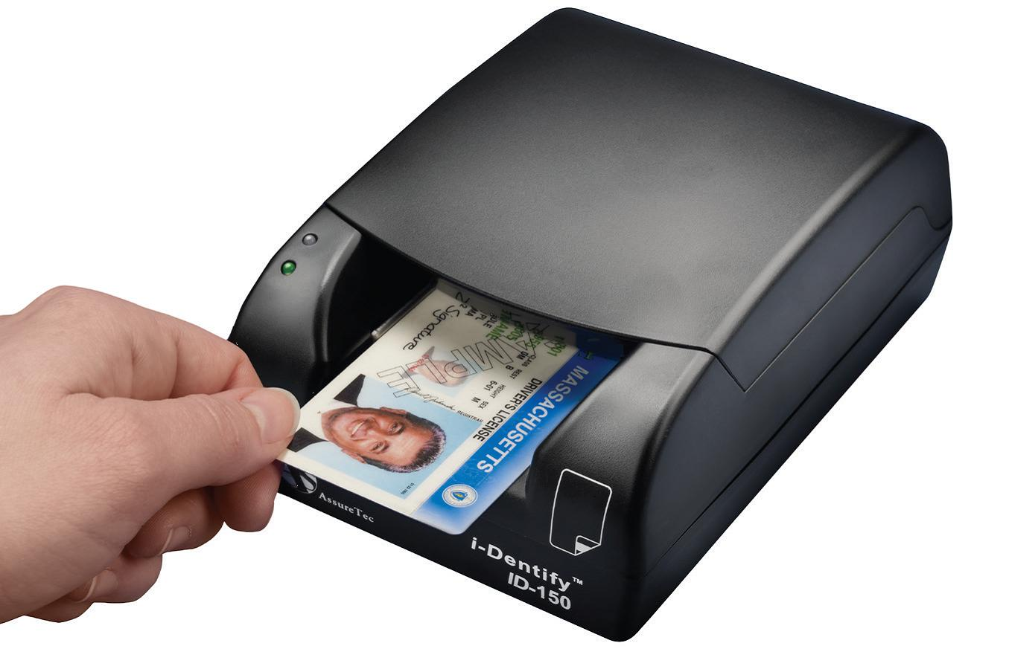

**Fig 3.4: ID card scanning system**

Drawback of the existing system:-

1. Since this process is manually human error can occurs.
2. The existing system is time consuming.
3. Less security.

Chapter 4

**Proposed System**

The available face recognition techniques can be classified into four categories based on the way they represent face.

* Appearance based which uses holistic texture features.
* Model based which employ shape and texture of the face, along with 3D depthinformation.
* Template based face recognition.
* Techniques using Neural Networks.

The Proposed system overcomes the problem of the existing system. This project uses the face recognition using the method of Neural Network Technique.



**Fig.4: Neural Network Technique**

In the proposed system when student come to the class or lecture system application is start. It works only is standing in front of the system (Computer application) the application capture the image and send the processing side. The processing side the application recognize the face of the student.

Finally the application mark as student present. If the face is not recognizing the application make as absent.

**4.1. Face Recognition Process:-**

**Declaring a Match**

**Comparison Templates**

**Extracting Features**

**Acquiring a sample**

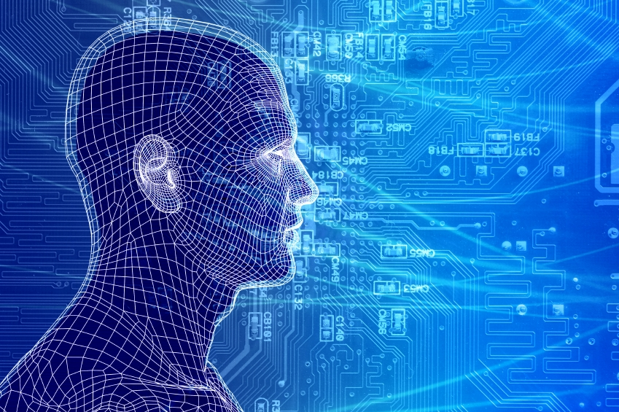

**Fig.4.2: Face Recognition Process**

* **Acquiring a sample:** In a complete, full implemented biometric system, a sensor takes an observation. The sensor might be a camera and the observation is a snapshot picture. In our system, a sensor will be ignored, and a 2D face picture “observation” will supplied manually

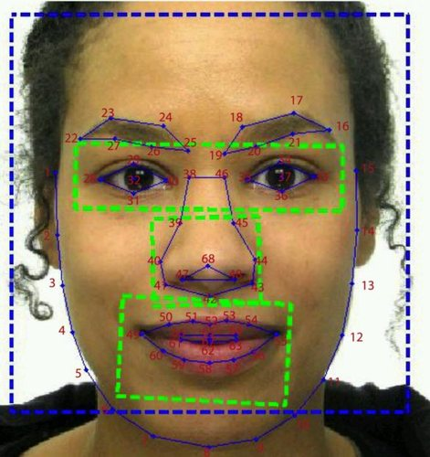.

**Fig.4.3: Acquiring a sample**

* **Extracting Features:** For this step, the relevant data is extracted from the predefined captured sample. This is can be done by the use of software where many algorithms are available. The outcome of this step is a biometric template which is a reduced set of data that represents the unique features of the enrolled user's face.

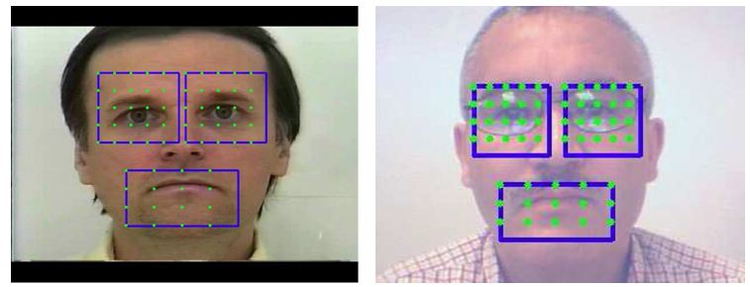

**Fig.4.4: Extracting Features**

* **Comparison Templates:** This depends on the application at hand. For identification purposes, this step will be a comparison between a given picture for the subject and all the biometric templates stored on a database. For verification, the biometric template of the claimed identity will be

retrieved (either from a database or a storage medium presented by the subject) and this will be compared to a given picture.

* **Declaring a Match:** The face recognition system will return a candidate match list of potential matches. In this case, the intervention of a human operator will be required in order to select the best fit from the candidate list. An illustrative analogy is that of a walk-through metal detector, where if a person causes the 7 detector to beep, a human operator steps in and checks the person manually or with a hand-held detector.

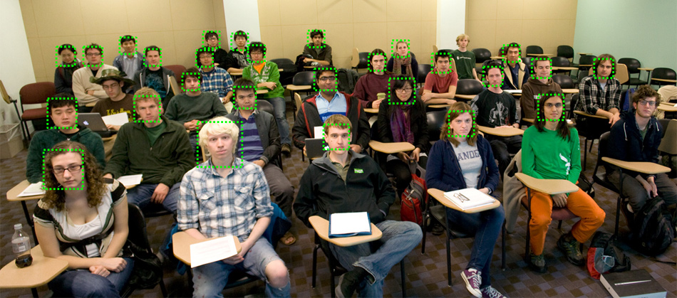

**Fig.4.5: Declaring a Match**

* This code is supposed to grab live camera feed, display feed in a window, mark in rectangles all detected faces, get the biggest detected face (by total area), display it in separate window, convert it to grayscale and finally save as PNG to hard disk, in project directory

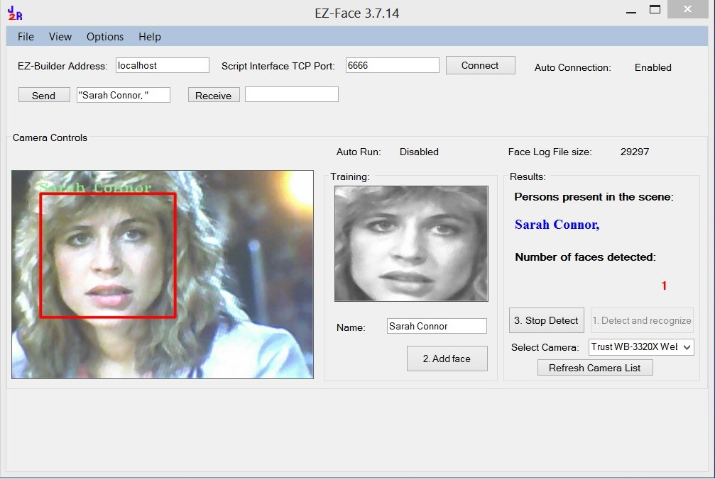

**Fig.4.6:Open CV Method**

Chapter 5

**Hardware and Software Requirement**

**5.1. HARDWARE**

|  |
| --- |
| 1. 1.66 GHz Pentium Processor or Intel compatible processor. |
| 1. 2GB RAM. |
| 1. 80 GB free hard disk space. |
| 1. Web Camera |

**Table 5.1: Hardware Requirements**

**5.2. SOFTWARE**

|  |
| --- |
| 1. Visual Studio 2008(.Net framework) |
| 1. .net |
| 1. MS SQL Server 2005 |

**Table 5.: Software Requirements**

**5.3. Microsoft SQL Server 2005**

Business today demands a different kind of data management solution. Performance scalability, and reliability are essential, but businesses now expect more from their key IT investment.

SQL Server 2005 exceeds dependability requirements and provides innovative capabilities that increase employee effectiveness, integrate heterogeneous IT ecosystems,and maximize capital and operating budgets. SQL Server 2005 provides the enterprise data management platform your organization needs to adapt quickly in a fast changing environment.

Benchmarked for scalability, speed, and performance, SQL Server 2005 is a fully enterprise-class database product, providing core support for Extensible Markup Language (XML) and Internet queries.

**5.3.1 Easy-to-use Business Intelligence (BI) Tools**

Through rich data analysis and data mining capabilities that integrate with familiar applications such as Microsoft Office, SQL Server 2005 enables you to provide all of your employees with critical, timely business information

Tailored to their specific information needs. Every copy of SQL Server 2005 ships with a suite of BI services.

**5.3.2Self-Tuning and Management Capabilities**

Revolutionary self-tuning and dynamic self-configuring features optimize database performance, while management tools automate standard activities. Graphical tools and performance, wizards simplify setup, database design, and performance monitoring, allowing database administrators to focus on meeting strategic business needs.

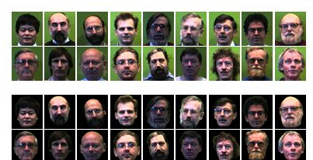

**Fig 5.3.4:Database**

**5.4. Activity diagram for Request data from database**

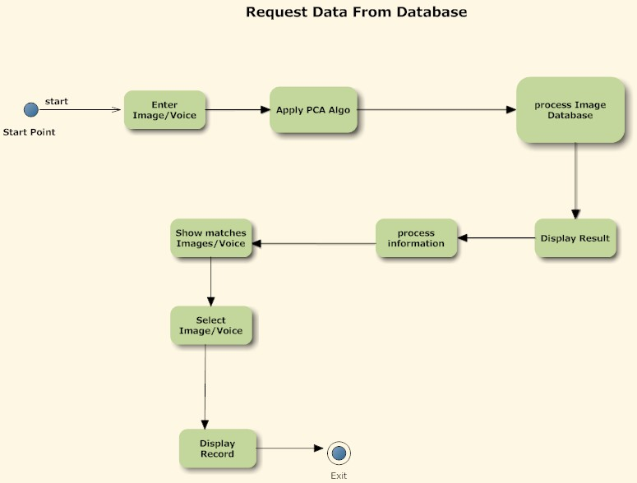

**Fig5.4.1:Request for database**

* When request accepted then the image we can insert into the database for permanent storing and then we can identify that image in the system

* PCA is a way of identifying patterns in data and expressing the data in such a way to highlight their similarities and differences . The purpose of PCA is to reduce the large
* dimensionality of the data space (observed variables) to smaller intrinsic dimensionality of feature space (independent variables) which are needed to describe the data economically.

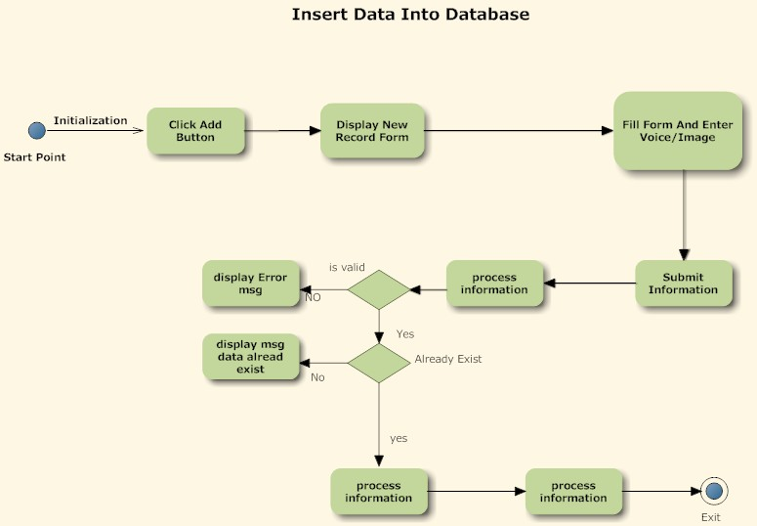

**Fig5.4.2:Insert into database**

* verify face recognition are functioning correctly, multiple users who are in the database as well as those who are not will need to test the system. The training library and recognition algorithms will also be modified as needed. One note is that we must make sure that the system rejects the users who are not in the database.

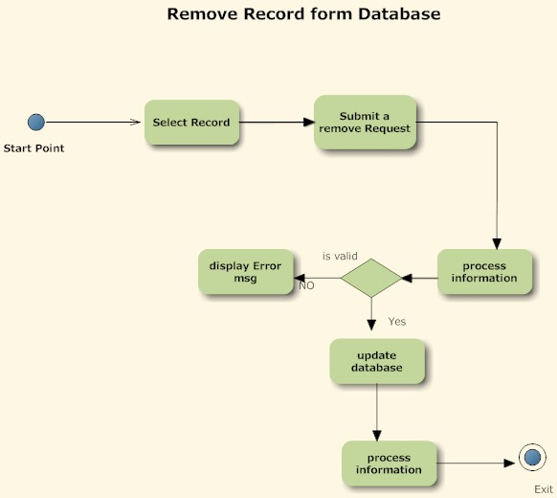

**Fig5.4.3:Remove from database**

Chapter6

**Implementation Plan for next semester**

The following table gives the project plan for the Phase 1 & 2 of our project:

|  |  |  |  |
| --- | --- | --- | --- |
| **Activity** | **Description** | **Effort in person weeks** | **Deliverable** |
| Phase 1 |  |  |  |
| P1-01 | Requirement Analysis | 2 weeks | Requirement Gathering |
| P1-02 | Existing System Study & Literature | 3 weeks | Existing System Study & Literature |
| P1-03 | Technology Selection | 2 weeks | MATLAB |
| P1-04 | Modular Specifications | 2 weeks | Module Description |
| P1-05 | Design & Modelling | 4 weeks | Analysis Report |
|  | **Total** | **13 weeks** |  |

**Table.6.1: Phase 1 of Implementation Plan**

|  |  |  |  |
| --- | --- | --- | --- |
| **Activity** | **Description** | **Effort in person weeks** | **Deliverable** |
| Phase 2 |  |  |  |
| P2-01 | Detailed Design | 2 weeks | LLD / DLD Document |
| P2-02 | UI and user interactions design | Included in above | UI document |
| P2-03 | Coding & Implementation | 12 weeks | Code Release |
| P2-04 | Testing & Bug fixing | 2 weeks | Test Report |
| P2-05 | Performance Evaluation | 4 weeks | Analysis Report |
| P2-06 | Release | Included in above | System Release |
|  | **Total** | **20 weeks** | Deployment efforts are extra |

**Table.6.2: Phase 2 of Implementation Plan**

Chapter 7

**Advantages**

* It is a fast, accurate and reliable than any other existing method.
* Face recognition is easy to use and in many cases it can be performed without person even knowing.
* Face recognition is also one of the most inexpensive biometric in the market and its price should continue to go down.
* There are many benefits to face recognition system such as its convinence and social acceptability

Chapter 8

**Application**

* The natural use of face recognition technology is the replacement of pin Government Use Law Enforcement minimizing victim trauma verifying identify for court record and comparing school surveillance camera images to know child molestor
* Security counterterrorism: Access control comparing surveillance images to know terrorist.
* Immigiration rapid progression through customs
* banking using atm the software is able to quickly verify a customer face
* Physical access control of building areas, doors or net access

Chapter 9

**Summary**

.

* As the number of training faces increases percentage of face recognition initially increases slightly, after reaching certain number, it remains same or decreases slightly, because of the increase in complexity of Artificial Neural Network architecture with number of training faces.

* The Variation in resolution of nose, mouth, and whole face or remaining portion of face does not affect the percentage of recognition much, but the variation in resolution of eye changes the percentage of face recognition significantly. Hence eyes are treated as more significant compared in face recognition.
* It is observed that when partial face features (face components- eyes, nose, and mouth) are used with Artificial Neural Network, it reduced percentage of recognition only by 4% to 8%, compared to the full face recognition with the same method.

* When only eyes are used in partial face recognition, the recognition rate reduced by 13% to 15% compared to full face recognition, and when only nose and mouth are used, it reduced by 18% to 20%.
* In face recognition using eigen features multi- scale face components and artificial neural networks, the performance of resulted four face recognition methods: 1) PCA+BP 2) PCA+RBF 3) LDA+BP and 4) LDA+RBF is evaluated on FERET & ORL databases in terms of percentage recognition with respect to resolution of face components, resolution of face, number of training faces, variation in training set, Artificial Neural Network structure and number of principal components, and the following conclusions are made based on the results obtained.

171

**REFERENCES**

1) H. Bay, T. Tuytelaars, and L. Van Gool. Surf: Speeded up robust

features. *ECCV*, 2006.

2)P. N. Belhumeur, J. P. Hespanha, and D. J. Kriegman. Eigenfaces vs.

fisherfaces: Recognition using class specific linear projection. *PAMI*,

1997.

3)F. L. Bookstein. Principal warps: Thin-plate splines and the decomposition

of deformations. *PAMI*, 1989.

4) W. Chen and Y. Gao. Recognizing partially occluded faces from a

single sample per class using string-based matching. In *ECCV*. 2010.

5) H. Chui and A. Rangarajan. A new point matching algorithm for

non-rigid registration. *CVIU*, 2003.

6) D. Conte, P. Foggia, C. Sansone, and M. Vento. Thirty years of graph

matching in pattern recognition. *PAMI*, 2004.

7)T. F. Cootes, G. J. Edwards, and C. J. Taylor. Active appearance

models. *PAMI*, 2001.

8)E. Elhamifar and R. Vidal. Robust classification using structured

sparse representation. In *CVPR*, 2011.

9)A. Georghiades, P. Belhumeur, and D. Kriegman. From few to many:

Illumination cone models for face recognition under variable lighting

and pose. *PAMI*, 2001.